Minh Nguyen

Assignment 4 questions

Due Date: 8/3/2014

Question 1: Show the binary search tree built by adding numbers in this specific order, assuming the graph is empty to start with: 50, 20, 100, 10, 130, 30, 21.

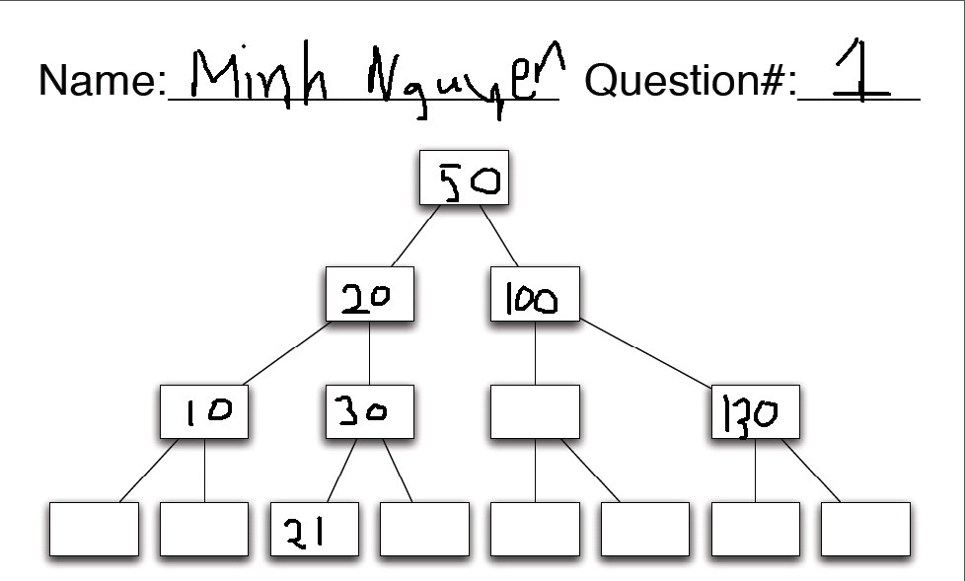

Question 2: The trouble with binary search trees is that they can become unbalanced depending on the order that you insert values. Give an order for inserting the values 1 through 7 such that the resulting tree is a full binary

search tree. This problem does not require you to fill in a tree, just write down the order in which you would

insert the values. (Hint: it might be helpful to first draw the full tree to figure out how the values must be

arranged, then you can determine the order to add them!)

- Add them in this order for balance: 4, 2, 6, 1, 3, 5, 7

Question 3: Part A: Given the following tree, question3.pdf, show the tree after removing the value 16.

Part B: Using the tree produced by Part A, show the tree after removing the value 17

A) 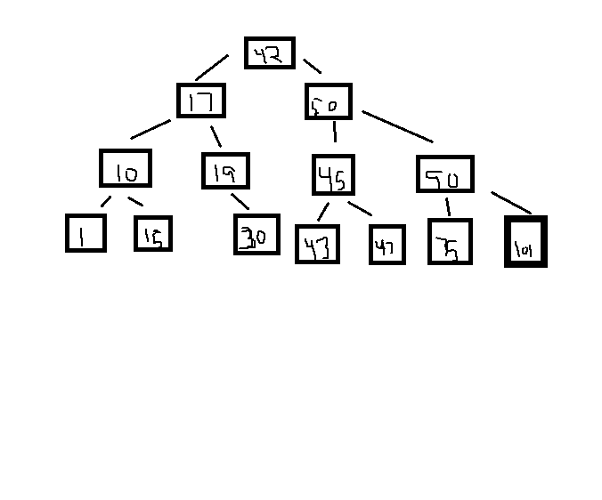B) 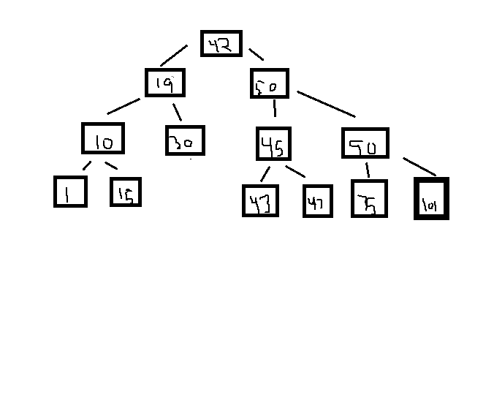

Question 4: 